12.84: a) From the result shown in Example 12.10, the force is attractive and its magnitude is proportional to the distance the object is from the center of the earth. Comparison with equations (6.8) and (7.9) show that the gravitational potential energy is given by

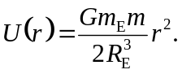
This is also given by the integral of 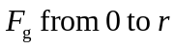 with respect to distance. b) From part (a), the initial gravitational potential energy is 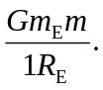 Equating initial potential energy and final kinetic energy (initial kinetic energy and final potential energy are both zero) gives 